APPENDIX C

Stormwater Control Plan Template for Small Projects/Single-Family Homes

Stormwater Control Plan For Small Projects/Single-Family Homes

Introduction
The California State Water Resources Control Board reissued the Phase II NPDES Permit for Small Municipal Storm Sewer Systems (MS4s) in February 2013. As of June 30, 2015, development projects that create or replace 2,500 square feet* or more of impervious surface must incorporate specified measures to reduce runoff. This requirement is part of the City of Rocklin’s comprehensive effort to reduce runoff pollution.
It is fairly easy to achieve compliance with the stormwater requirements for small land development projects. Compliance for each project must be carefully documented. Please complete the following form and submit it as directed by Environmental Services Department staff.
In addition, staff will review your site plan to confirm that the following design strategies have been incorporated into your project:
- Limit disturbance of creeks and natural drainage features
- Minimize compaction of highly permeable soils
- Limit clearing and grading of native vegetation at the site to the minimum area needed to build the project, allow access, and provide fire protection
- Minimize impervious surfaces by concentrating development on the least-sensitive portions of the site, while leaving the remaining land in a natural undisturbed state
*Projects that create or replace 5,000 square feet or more of impervious surface, except for detached single- family homes, require a comprehensive Stormwater Control Plan for Regulated Projects.
Step-by-Step Instructions
The steps are:
- Fill out the Project Data Form (an editable form is available online at www.rocklin.ca.us/LID) and select one or more runoff reduction measures.
- Prepare a site plan or sketch. Specify and design the runoff reduction measures you will use to meet the stated minimum requirements.
- Complete your submittal, which will include:
  - Project Data Form
  - Site Plan or Sketch
  - Completed checklist for each Runoff Reduction Measure selected

Step 1: Project Data Form and Runoff Reduction Measure Selection
Complete all fields.

Project Name
Application Submittal Date
[to be verified by Environmental Services staff]
Project Location
[Street Address if available, or intersection and/or APN]
Name of Owner or Developer
Project Type and Description
[Examples: “Single Family Residence,” “Parking Lot
Addition,” “Retail and Parking”]
Total Project Site Area (acres)
Total New or Replaced Impervious Surface Area (square feet)
[Sum of impervious area that will be constructed as part of
the project]
Total Pre-Project Impervious Surface Area
Total Post-Project Impervious Surface Area
Runoff Reduction Measures Selected  (Check one or more) | - Disperse runoff to vegetated area  - Pervious pavement  - Cisterns or Rain Barrels  - 4. Bioretention Facility or Planter Box

Step 2: Delineate impervious areas and locations of runoff reduction measures
Delineate the impervious area. On a site plan or sketch, show the impervious area—for example, a roof, or portion of a roof, or a paved area—that will drain to your runoff reduction measure. Typically these delineations follow roof ridge lines or grade breaks. Alternatively, show the type and extent of pervious paving. An example sketch is attached.
Indicate the location and kind of runoff reduction measure you’ve selected. At least one option, designed to manage runoff from some amount of impervious area—or to avoid creating runoff—is required.
For each option selected, there is a brief checklist to confirm your design and your submittal meet minimum requirements.

Step 3: Complete and submit your plan
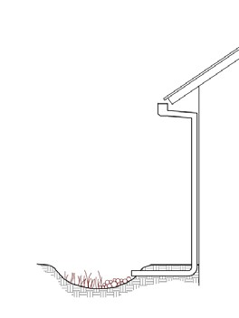
Consult with municipal staff about when and how to submit your Stormwater Control Plan.
Connecting a roof leader to a vegetated area. The head from the eave height makes it possible to route roof drainage some distance away from the building.
Runoff Reduction Options

Option 1: Disperse runoff from roofs or pavement to vegetated areas.
This is the simplest option. Downspouts can be directed to vegetated areas adjacent to buildings, or extended via pipes to reach vegetated areas further away. Paved areas can be designed with curb cuts, or without curbs, to direct flow into surrounding vegetation.
On the site plan, show:
- Each impervious area from which runoff will be directed, and its square footage
- The vegetated areas that will receive runoff, and the approximate square footage of each
- If necessary, explain in notes on the plan how runoff will be routed from impervious surfaces to vegetated areas
Confirm the following standard specifications are met:
- Tributary impervious square footage in no instance exceeds twice the square footage of the receiving pervious area.
- Roof areas collect runoff and route it to the receiving pervious area via gutters and downspouts.
- Paved areas are sloped so drainage is routed to the receiving pervious area.
- Runoff is dispersed across the vegetated area (for example, with a splash block) to avoid erosion and promote infiltration.
- Vegetated area has amended soils, vegetation, and irrigation as required to maintain soil stability and permeability.
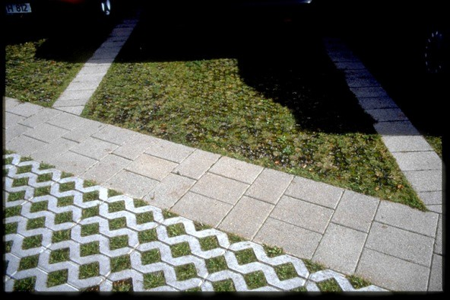
- Any drain inlets within the vegetated area are at least 3 inches above surrounding grade.

Option 2: Permeable Pavement
This option can be easy to install and maintain, cost-effective, and can add aesthetic value to your project. Permeable pavements may include pervious concrete, pervious asphalt, porous pavers, crushed aggregate, open pavers with grass or plantings, open pavers with gravel, or solid pavers.
Show on your site plan:
- Location, extent and types of pervious pavements
Confirm the following standard specifications are met:
- No erodible areas drain on to permeable pavement
- Subgrade compaction is minimal
- Reservoir base course is of open-graded crushed stone. Base depth is adequate to retain rainfall (3 inches is adequate) and support design loads (more depth may be required).
- No subdrain is included or, if a subdrain is included, outlet elevation is a minimum of 3 inches above bottom of base course.
- Subgrade is uniform and slopes are not so steep that subgrade is prone to erosion.
- Rigid edge is provided to retain granular pavements and unit pavers.
- Solid unit pavers, if used, are set in sand or gravel with minimum 3/8 inch gaps between the pavers. Joints are filled with an open-graded aggregate free of fines.
- Permeable concrete or porous asphalt, if used, are installed by industry-certified professionals according to the vendor’s recommendations.
- Selection and location of pavements incorporates Americans with Disabilities Act requirements (if applicable), site aesthetics, and uses.
Option 3: Cisterns or Rain Barrels
Use of cisterns or rain barrels to comply with this requirement is subject to City approval by Environmental Service staff. Planning and Building Permits may be required for larger systems.
Show on your site plan:
- Impervious areas tributary to each cistern or rain barrel
- Location of each cistern or rain barrel
Confirm the following standard specifications are met:
- Rain barrels are sited at grade on a sound and level surface at or near gutter downspouts.
- Gutters tributary to rain barrels are screened with a leaf guard or maximum ½-inch to ¼-inch- minimum corrosion-resistant metallic hardware fabric.
- Water collected will be used for irrigation only.
- Openings are screened with a corrosion-resistant metallic fine mesh (1/16 inch or smaller) to prevent mosquito harborage.
- Large openings are secured to prevent entry by children.
- Rain barrels and gutters are to be cleaned annually.
- The local mosquito and vector control district is informed of the installation. The district will be provided additional information and/or rights of entry if they request.
Option 4: Bioretention Facility or Planter Box
An above-ground planter box may be appropriate if the development site lacks level landscaped areas for dispersion and pervious pavements are not practical. Planter boxes and bioretention facilities can treat runoff from impervious surfaces 25 times their area (sizing factor of 0.04).
Detailed design guidance for bioretention facilities is in the Stormwater Technical Guide.
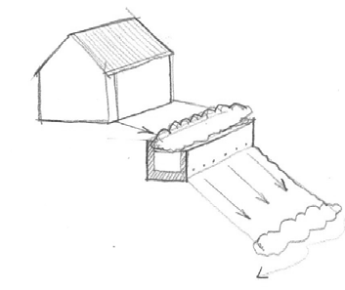
Show on your site plan:
Flow through planter built into a hillside. Flows from the underdrain and overflow must be directed in accordance with City requirements.
- Impervious areas tributary to the planter box
- Location and footprint of planter box Confirm the following standard specifications are met:
- Reservoir depth is 4"-6" minimum.
- 18" depth soil mix with minimum long-term infiltration rate of 5"/hour. See http://www.cccleanwater.org/c3-guidebook.html for a list of soil mix suppliers.
- Surface area of soil mix is a minimum 0.04 times the tributary impervious area.
- “Class 2 perm” drainage layer 12" deep.
- No filter fabric.
- Perforated pipe (PVC SDR 35 or approved equivalent) underdrain with outlet located flush or nearly flush with planter bottom.
- Connection with sufficient head to storm drain or discharge point.
- Underdrain has a clean-out port consisting of a vertical, rigid, non-perforated PVC pipe, connected to the underdrain via a sweep bend, with a minimum diameter of 4" and a watertight cap.
- Overflow outlet connected to a downstream storm drain or approved discharge point.
- Planter is set level.
- Emergency spillage will be safely conveyed overland.
- Plantings are suitable to the climate, exposure, and a well-drained soil.
- Irrigation system with connection to water supply, on a separate zone

Useful Resources

The following references may be useful for design. Designs must meet the minimum standard specifications herein.

City of Rocklin Post-Construction Manual

SPC Water Resource Center

Concrete Promotion Council of Northern California
California Asphalt Pavement Association
Interlocking Concrete Pavement Institute http://www.icpi.org/

Porous Pavements, by Bruce K. Ferguson. 2005. ISBN 0-8493-2670-2

Example Sketch

The example below illustrates the level of detail required.

Not to Scale

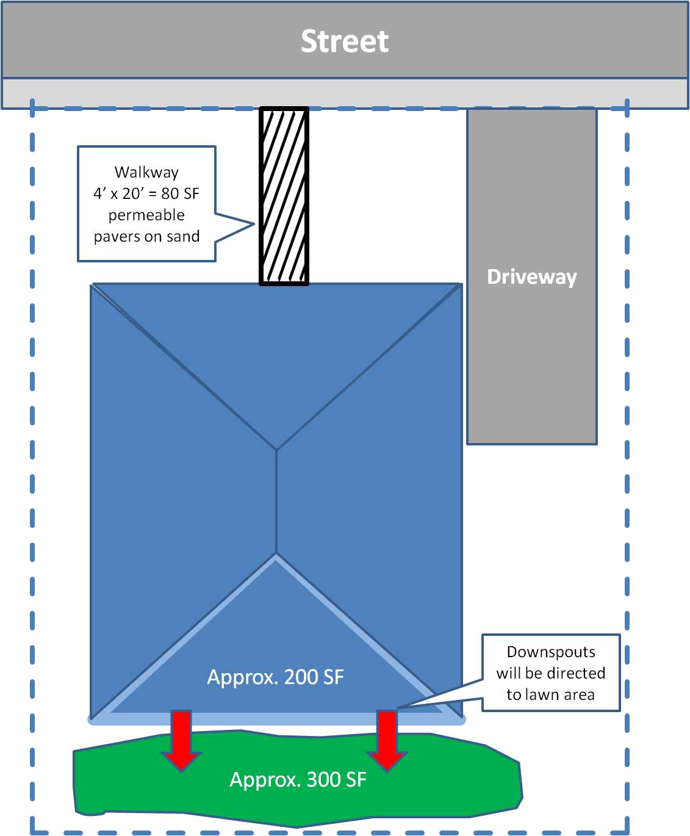
16’

10’

25’

